

Occupational Health & Safety

Policy and Procedures

CONDITIONS OF USE

This product is the property of the NSW Department of Education and Training and its use is subject to the provisions of the Copyright Act 1968. It may not be reproduced by whatever means or used or modified for the purpose of generating income through sale or licensing without the prior written permission of the copyright owner.

Any inquiries concerning use of the product, for purposes other than its stated intention, should be directed to:

The Director
Business and Public Administration Division (B&PA Division)
Sydney Institute (PO Box 707 Haymarket NSW 2007)
Level 2, Building C
Mary Ann Street
ULTIMO NSW 2007
Ph: (02) 9217 4400
Fax: (02) 9217 4015

Contents

Occupational Health and Safety
Introduction 1
Management Responsibility
Health and Safety Policy 2
Consultation and Communication
OHS Consultation Statement 3
Occupational Health & Safety Committee
OHS Committee 5
OHS Committee – Election Procedures 6
OHS Committee – Meeting Procedures 7
Risk Management and Process Control 9
Hazard Identification Checklist 10-15
Risk Assessment Guidelines 16
Hazard Control Report form 17
Safe Purchasing Procedures and Checklist 18
Workplace Injury Management 19
Hazard, Incident and Injury Reporting Procedures 20
First Aid Assistance 21
First Aid Requirements and Reporting 22
First Aid Treatment Card 23
Accident/Incident Report Form 24-26
Register of Injuries 27
Register of Injuries – Inside Cover 28
Register of Injuries – Form 29
WorkCover NSW Medical Certificate 30
Total Insurance Workers Compensation (NSW) Limited –
Fax Form for Initial Notification of Injury 31
WorkCover Incident Report Form 32-35
Workers Compensation 36
Poster – Summary of Workers Compensation Act 1998 37
WorkCover NSW Workers Compensation Claim Form 38-39
Return to Work Program 40-41
Procedures – Return to Work Program for Injured Workers 42-43
Checklist - Managing the Return to Work Plan 44
Form - Return to Work Plan 45-46
Training and Skills Development
OHS Induction Training Program 47
Induction Checklist for New Employees 48
OHS Training Programs 49
Training Strategy for 2002-2003 50
Management Training Strategy 51
Manager Training Strategy 52
Employee Training Strategy 53
Sources for Further Reference
OHS Library 54
Internet Websites 55

Introduction

Swaggies Pty Ltd is committed to the protection of all staff and visitors from injury and occupational disease and is committed to following all relevant state and federal legislation. The purpose of this manual is to provide easy access for all staff to the policies, procedures and documentation that form our OHS management system.

The company’s commitment to occupational health and safety includes -
- Preventing injury or illness to all staff members and visitors by providing a safe and healthy work environment
- Ensuring the work environment as well as work practices are safe and hazard free
- Providing staff with all necessary training and access to information to achieve a safe and healthy workplace
- Providing worker’s compensation insurance as required by law
- Providing a rehabilitation program to assist staff returning to work after a work injury
- Ensuring that all workstations are equipped with high-quality ergonomically designed furniture to minimise health risks to staff.

All staff are required to -
- Take reasonable care of the health and safety of themselves and others
- Co-operate with the company in its efforts to comply with occupational health and safety requirements
- Make every reasonable effort to reduce the risk of injury by reporting faulty equipment and any unsafe work practices or potential health risks
- Complete an Accident/Incident Report Form as soon as possible after an incident occurs
- Attend training sessions in emergency procedures and familiarise themselves with the company’s guidelines concerning manual lifting and handling, occupational overuse syndrome and stress management
- Use all equipment correctly and comply strictly with the manufacturer’s instructions.



Health and Safety Policy

The management of Swaggies Pty Ltd is committed to providing and maintaining a safe and healthy working environment for its employees and anyone entering upon its premises or with connection to the company’s business operations.

In demonstrating management’s duty of care, we will make every reasonable effort to provide a working environment that minimises incidents of risk or personal injury, ill health or damage to property.

- Providing employees with appropriate training
- Providing safe plant and equipment and systems of work
- Regular consultation on health and safety issues

A safe working culture is the responsibility of everyone and this can be best achieved through cooperative efforts of employees. A safe culture will be reinforced through –

- continually identifying, assessing and controlling possible risks to the health and safety of people that may arise in the workplace
- the provision of information concerning such risks and the promotion, instructions, training and supervision of employees to ensure safe work practices.
- giving employees and customers the opportunity to participate in health and safety decisions that affect them

In the interests of maintaining safety, contractors and their employees, visitors and customers are required to observe and comply with all health and safety standards and rules produced. This includes any safety signage or warnings, or instruction given by any company employee whilst on our premises

Signature |  | Signature | 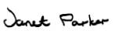
 | Managing Director |  | Employee Representative
Date | 12 March 2001 | Date | 12 March 2001

Review Date | 12 March 2003

Note - a framed copy of the Health & Safety Policy must be displayed
in the Reception area
Filename: HR Department\OHS\OHS Policies\Health and Safety Policy.doc

OHS Consultation Statement

Company Commitment
Swaggies Pty Ltd is committed to protecting the health and safety of all our employees. Injury and illness is needless, costly and preventable. Our company will consult our employees in implementing safety practices and systems that will ensure the health, safety and welfare of our employees. Employee involvement at all levels is critical for ensuring a safe workplace.

An OHS Committee and OHS Representatives will be established to promote safety and health in the workplace.

Establishment of Consultation Arrangements
Swaggies Pty Ltd discussed establishing consultation arrangements with its employees in February 2001. After a number of information sessions and small group workshops with all employees, it was agreed to establish OHS Representatives and an OHS Committee.

OHS Representatives
The OHS Representatives that have been elected by employees are

- Janet Parker, Administration and HR Workgroup
- Mary Anderson, Purchasing and Accounts Workgroup
- Rebecca Wilson, Sales & Marketing Workgroup
- Peter Hill, Warehouse Workgroup.

The OHS Representatives have been elected in accordance with the procedures agreed between Swaggies Pty Ltd and their employees for 2-year terms.

The OHS Representatives are responsible for raising specific health and safety issues that arise in relation to the employees in their workgroups. Employees should raise OHS issues directly with their supervisor or their OHS representative. Where the OHS Representative cannot resolve an OHS issue, it has been agreed that they will refer it to the OHS Committee.

OHS Committee
The OHS Committee shall consist of four employee representatives and two employer representatives.

The workgroup for the OHS Committee is all employees who work for Swaggies Pty Ltd at 361 Sydney Road, Manly, NSW.

The employee members of the OHS Committee are the four OHS Representatives listed above. The management representatives are

- Steve Parsons, Managing Director
- Lyn Singh, Human Resources Manager

The OHS Committee will assist with the development and monitoring of safe work practices and systems, and discuss issues that affect the health, safety and welfare of all employees at Swaggies Pty Ltd. The company will respond to OHS Committee recommendations within a timeframe agreed by the Committee, set according to the particular issue and its complexity.

OHS Consultation Statement (con’td)

How Employees will be Consulted about OHS
When an OHS issue is raised either by the company, an employee or the OHS Committee, the OHS Representative will consult members of their workgroup. The OHS Representative will consult members of their workgroup. The OHS Representative will also feed back to their workgroup the outcomes of the OHS Committee meetings.

Employees should draw to the attention of their supervisor or OHS Representative any health and safety concerns that they have about the workplace so the issue can be promptly addressed.

Review of Consultation Arrangements
To ensure that consultation with all employees is effective and that all safety issues are being addressed, it has been agreed by Swaggies Pty Ltd and their employees that these OHS consultation arrangements will be monitored and reviewed on an on-going basis.

Signed |  | Managing Director
Date | March 2001

Filename: HR Department\OHS\OHS Policies\ConsultationStatement.doc

OHS Committee

- Swaggies OHS Committee consists of four employee representatives and two employer representatives

- Committee members are elected for two years (the Regulation 7 [6])

- Committee members must undertake OHS Consultation Training (Regulation 31 [1]). This includes employee and employer members of the OHS Committee.
(Information about OHS Consultation Training ‘Topics’ and ‘Learning Outcomes’ is listed on pages 56-58, OHS Consultation Code of Practice 2001)

Employee Representatives elected November 2000

Janet Parker Administration and HR Workgroup
Mary Anderson Accounts and Purchasing Workgroup
Rebecca Wilson Sales & Marketing Workgroup
Peter Hill Warehouse Workgroup

Management Representatives

Steve Parsons Managing Director
Lyn Singh Human Resources Manager

Meetings

- OHS Committee Meetings are held once every three months – the second Monday of that month.
- The Chairperson of the meeting must be one of the employee representatives.

- An agenda is prepared and circulated to all committee members five days before each meeting. (the Regulation clause11 [2] [c]). The agenda should also be displayed prominently in the workplace.
Agenda forms can be located in the General Stationery folder.
Copies of the agenda are to be displayed on the notice boards located in the Reception area and the Warehouse.

- Minutes should be kept of each meeting (the Regulation clause 11 [2] [d]).
Minutes of Meeting forms can be located in the General Stationery folder.

- Copies of the minutes should be distributed to all committee members

- Copies of the minutes should also be displayed prominently in the workplace (the Regulation clause 11 [2] [a]).
Copies of the minutes are to be displayed on the notice boards located in the Reception area and the Warehouse.

- Records of the committee (including minutes of meetings) must be stored and be accessible to all committee members (the Regulation clause 11 [2] [e] and [f]).
All computer files relating to OHS Committee records are to be stored in the folder -HR\OHS\Committee Records

OHS Committee - Election Procedures

Step 1 | Agree on a Returning Officer  The role of the Returning Officer is to conduct the election process. The Returning Officer should be an employee. At least 50 per cent of the workgroup should agree on the Returning Officer. The Returning Officer should not nominate for any position being elected, but may vote in the election.
Step 2 | Invite nominations  The Returning Officer should display notices where employees are likely to see them inviting nominations (eg Noticeboard in Reception). The notice should state –  - The purpose of the election (eg, ‘to elect on OHS Representative’, or, ‘to elect employee members of an OHS Committee’)  - The day and time nominations close  - How or where nominations can be lodged (eg by advice to the Returning Officer)  - The day, time and place the election is to be held  - The name of the workgroup (eg the Warehouse Workgroup)  - The name and contact details of the Returning Officer  The employer and the Returning Officer should give consideration to ensuring that employee from non-English speaking backgrounds understand the election process to ensure their participation.
Step 3 | Examine the nominations  At the day, time and place nominations were advertised to have closed, the Returning Officer should examine the nominations received. Nominations need not be in writing, but could form an expression of interest from the person concerned made direct to the Returning Officer.  In the event that only one nomination is received, the Returning Officer should declare that person elected unopposed.  Where more than one nomination is received, a formal election should be held.  Ballot papers should be prepared that clearly list the name of all candidates in alphabetical order.
Step 4 | Hold the election  At the advertised day, time and place of the election, employees eligible to vote should collect one ballot paper each.  The ballot papers should be filled in at the same time. Employees should be given the opportunity to fill in the ballot papers in private.  The Returning Officer should declare the candidate who receives the most number of votes elected. In the event that the vote is tied, the result should be determined as agreed when establishing the election procedures. For example -  - By drawing a candidate’s name out of a hat  - By holding a new election  - By electing both candidates

OHS Committee - Meeting Procedures

Before any meeting

- The Chairperson should plan a draft agenda for the meeting by –
  - reviewing the previous minutes and checking the status of outstanding issues
  - consulting with other OHS Committee members to see if they want issues put on the agenda
  - allowing adequate time on the agenda for major issues
  - checking that the agenda does not contain too many agenda items. If so, items should be prioritised to see if minor issues could be resolved outside the OHS Committee.

- OHS Committee members should receive a copy of the draft agenda at least five (5) days before the meeting. This timeframe will allow members to think about issues, or discuss them with relevant employees or managers.

- A copy of the draft agenda for the next meeting should be displayed where all employees will see it. This will enable employees to provide input to OHS Committee members prior to the meeting.

At every meeting

The Chairperson should ensure that –

- the meeting starts and finishes on time
- apologies or absences are recorded
- the OHS Committee members agree on the draft agenda including whether appropriate time has been allocated for each item. Review, revise and reorder agenda if necessary
- the minutes of the last meeting are reviewed and approved as an accurate record, or amended as necessary
- the meeting hears a report-back on any matters listed for action in the minutes of the last meeting
- the meeting works through the agenda in a business-like fashion. Avoid getting bogged down on minor points (which may be able to be addressed outside the meeting with a report-back to the OHS Committee) and side-tracked by issues not on the agenda (the OHS Committee can consider these issues in General Business or at the next meeting as agreed).

During the meeting

All OHS Committee members should –

- focus on resolving problems by considering the appropriate recommendations to put to management.
- support the Chairperson in ensuring the meeting keeps on track and doesn’t get bogged down.

At the end of the meeting

All OHS Committee members should –

- ensure that there are clear outcomes from the meeting. Establish action items and responsibilities (What has been decided? Who is going to follow through on the decision? When will that happen? )
- agree on a date and place for the next meeting
- spend a few minutes evaluating the meeting. (Did the meeting follow the agreed agenda? Was the desired outcome achieved? Are there clear action items and responsibilities?)

After the meeting

The Chairperson (with the assistance of the employer and/or other OHS Committee members as appropriate) should ensure –

- minutes of the meeting are written up
- persons responsible for actioning items are clear on what the OHS Committee expects them to do
- The meeting minutes are distributed to OHS Committee members
- The meeting minutes are displayed where all employees will see them.

For more information about OHS Committees, refer to OHS\Publications folder –
- OHS Consultation, Code of Practice 2001, WorkCover NSW,
- A Guide to Workplace Health and Safety Committees, WorkCover NSW, August 1998
- Participating in Effective Occupational Health and Safety Committees: A guide for Committee Members, Comcare Australia, 1999.

Risk Management and Process Control

Swaggies has adopted a risk management approach in addressing occupational health and safety issues. This involves –

Hazard Identification
Identifying all those things that may cause illness or injuries. This can involve equipment, machinery and chemicals used, the physical demands of the task, and aspects of the work environment such as noise or air quality.
⇩
Risk Assessment
Determining how likely and how serious the effects will be on people in the workplace being exposed to the hazard.
⇩
Risk Control
Deciding and then implementing what needs to be done in order to eliminate or control the risks to health and safety.

Step 1 – Hazard Identification
Every three months the HR Department will distribute a Hazard Identification Checklist to all employees. You will be requested to -
- use the Hazard Identification Checklist (refer p 10) to carry out a hazard inspection of your work area
- identify any hazards and provide comments as necessary on the checklist
- return the completed checklist to the Human Resources Manager within seven days
- discuss with your Manager and other employees ways you could prevent or rectify any identified hazards
- take the necessary steps to rectify or prevent the identified hazards you have identified

Step 2 – Risk Assessment
Upon receipt of the completed Hazard Identification Checklists, the HR Department will –
- review the checklists
- carry out a risk assessment in order to assess the exposure and severity of the hazards identified (refer ‘Risk Assessment Guidelines, p 16)
- check the status of any hazards requiring attention
- consult with employees and OHS Committee regarding solutions proposed/taken in order to eliminate hazards

Step 3 – Risk Control
The Human Resources Department will then take the required response actions for the identified hazards by –
- completing a Hazard Control Report (refer page 17)
- forwarding copies of the report to OHS Committee members. At the next OHS Committee Meeting, the committee reviews all hazards reported and preventative action taken since their last meeting.

The OHS Committee also carries out four Workplace Audits each year - February, May, August and November.

Hazard Identification Checklist

Note: this form will soon be available in the HR Department\OHS\Forms folder

Hazard Identification Checklist – page 2
Hazard Identification Checklist – page 3
Hazard Identification Checklist – page 4
Hazard Identification Checklist – page 5
Hazard Identification Checklist – page 6

Risk Assessment Guidelines

Hazard | Dept | Exposure Rating*  Choose rating 1 to 4 | Severity Rating**  Choose rating  1 to 5 | Risk Priority  High, Medium Low | Response Action  (Refer to Hierarchy of Controls listed below)

*Exposure Rating  - very likely (could happen frequently)  - likely (could happen, but not frequently)  - unlikely (could happen, but only rarely)  - highly unlikely (could happen, but probably never will) | **Severity Rating  - fatal (may cause one or more fatalities)  - critical (may cause more than 2 weeks lost time)  - major (may result in 1-2 weeks lost time)  - minor (may cause 1 weeks lost time)  - negligible (First Aid treatment only – no lost time)

Hierarchy of Controls
Level 1 (best)  Eliminate the risk | Eliminate | The best way to correct a safety problem is to eliminate the hazard (eg replace faulty wiring, or remove/relocate equipment/ machinery). If the hazard cannot be eliminated, then consider the options below.
Level 2  Minimise the risk | Substitute | Replace the hazardous substance, machine or tasks with a safe one.
(as above) | Engineer | Modify the tools or equipment, enclose the equipment, put guards in place
Level 3  Develop other control measures | Administration | Develop and implement safe procedures and training for hazardous jobs
(as above) | Personal Protective Equipment | Personal protective equipment (eg safety glasses, footwear and hearing protection) are important but should be used only when other measures are not practicable.

Filename: HR Department\OHS\Forms\Risk Assessment Guidelines.doc

Hazard Control Report

Note - refer to Risk Assessment Guidelines when completing this report

Hazard  (Problem) | Dept | Risk  (Harm) | Controls  (Solution)

Report prepared by
Date

Filename: HR Department\OHS\Forms\Hazard Control Report.doc

Safe Purchasing Procedures

Caution should be exercised when purchasing equipment, machinery and products as these items may involve safety issues. For this reason purchasing procedures should include identification of hazards and assessment of risk.

The checklist shown below will provide you with a guide towards safe purchasing.

Safe Purchasing Checklist
 | What is the proposed purchase item?
 | What safety information has been obtained regarding the item? | ◻ Equipment Manual ◻ Australian Standards  ◻ Manufacturer’s Safety Data Sheet ◻ Other Safety Information
 | Which employees and work processes are affected by the purchase?
 | Have the affected employees been consulted? When?
 | What are the health and safety risks relevant to the purchase?
 | How will the purchase help manage these risks?
 | What has to be done to ensure the use, storage and transport of the purchase is safe?
 | What change will need to be made to Safe Work Procedures?
 | What training will be required before the use of the purchase?

Filename: HR Department\OHS\Forms\Safe Purchasing Checklist.doc

Workplace Injury Management

The Workplace Injury Management and Workers Compensation Act 1998 focuses on the management, prevention and administration of workplace injuries. The emphasis is on a safe, timely and durable return to work of injured workers.

There are two programs available to assist injured workers –

- Injury Management Program
An Injury Management Program is a coordinated and managed program that integrates all aspects of injury management including treatment, rehabilitation, re-training, claims management and employment management practices to achieve optimum results.
The responsibility for establishing this program lies with our insurance company, Total Insurance Workers Compensation (NSW) Limited, who must lodge a copy of the program with WorkCover.

- Return to Work Program
Swaggies Pty Ltd is required to establish a Return to Work Program that incorporates the policies and procedures for the rehabilitation of injured workers. The program must follow the WorkCover Guidelines for Employer’s Return-to-Work Programs*.
This program nominates our ‘Return to Work Coordinator’, lists the rehabilitation providers who will work with us on the program, and describes how suitable duties will be made available for workers who are certified fit for such duties.
Pages 42-46 of this manual will provide you with more information about this program.

*The publication, WorkCover Guidelines for Employer’s Return-to-Work Programs, can be accessed from the OHS Library folder – filename rtw_guide.pdf

Hazard, Incident and Injury Reporting Procedures

Step 1 | Employees –  - You should report all hazards, incidents and injuries to your Manager as soon as possible  - When an injury has occurred, you should complete an Accident/Incident Report Form and give to your Manager as soon as possible after the incident. (A copy of this form is shown on page 24.)  - You must also enter details of your injury in the Register of Injuries. This Register is available from the HR Assistant. (A copy of this Register is shown on pages 27-29.)  - If you require medical treatment, then obtain a WorkCover NSW Medical Certificate from your treating doctor and then give this certificate to your Manager. (A copy of this Certificate is shown on page 30.)  - Ask your Manager to contact the insurance company (if incident involves claiming Workers Compensation).  - Keep in contact with your Manager and the insurance company while you are recovering from your injury  - Keep a copy of any documents relating to your injury.
Step 2 | The Department Manager – when a hazard, incident or injury is reported …  - ensures First Aid is provided, if required. (Refer First Aid Assistance, p 21)  - immediately refers the Accident/Incident Report form to HR Manager  - investigates cause of hazard, injury or incident and either fixes problem or takes remedial action  - requests the HR Manager to contact the insurance company (if applicable)
Step 3 | The HR Manager – reviews the Accident/Incident Report and …  - ensures that remedial action is appropriate  - notifies WorkCover of any work-related incident – refer WorkCpver Incident Report Form on pages 32-35  - within 48 hours, if the incident involves a Workers Compensation claim, sends the Fax Form for Initial Notification of Injury to the workers compensation insurer, Total Insurance Workers Compensation (NSW) Ltd.  (A copy of this form is shown on page 31.)  - commences consultation procedures for Injury Management Program and Return to Work Plan, if applicable (refer pages 42-43)  - if appropriate, completes a Hazard Control Report form (refer page 17)  - takes any further action to ensure safety  - advises Managing Director of action taken.
Step 4 | Managing Director – reviews all action taken

First Aid Assistance

First Aid Kit   | The First Aid kit is located in the  Administration Department
First Aid Assistance | For first aid assistance contact …..  Janet Parker, Administration Manager  Extension 566  Janet Parker is our company’s first aider and she has received basic workplace first aid training.  In her absence, call Lyn Singh, HR Manager on Ext 572
Emergency Numbers | Ambulance, Fire, Police 000  - Remain calm – do not hang up  - Speak clearly and provide details as required  - If requested, be prepared to evacuate the premises  Poisons Information Centre 13 1126  Medical Centre 977 1001  Hospital 977 1234

Note – a copy of this page should be displayed in each department
Filename: HR Department\OHS\Forms\First Aid Assistance Chart.doc

First Aid
Requirements and Reporting

First Aid Kit Requirements | - A Type B First Aid Kit to cater for cuts, lacerations and amputations is kept in the Administration Department.  - Janet Parker, the first aid officer, is responsible for maintaining the first aid kit.  - Contents of the Type B First Aid Kit are shown below.
First Aid Recording and Reporting | - All first aid treatment should be recorded on a First Aid Treatment Record Card. This card is located inside the First Aid Kit.  - A copy of the First Aid Treatment Record Card is shown on page 23.  - At the end of each year (December), a copy of all First Aid Treatment Record Cards should be sent to the HR Manager.

First Aid Kit – Type B
Description of Appliance or Requisite | Contents
Adhesive plastic dressing strips, sterile, packets of 50 | 1
Adhesive dressing tape, 2.5 cm x 5 cm | 1
Bags, plastic, for amputated parts: small | 1
medium | 1
large | 1
Dressing, non-adherent, sterile, 7.5 cm x 7.5 cm | 2
Eye pads, sterile | 2
Gauze bandages 5 cm | 1
10 cm | 1
Gloves, disposable, single | 4
Rescue blanket, silver space | 1
Safety pins, packets | 1
Scissors, blunt/short-nosed, minimum length 12.5 cm | 1
Splinter forceps | 1
Sterile eyewash solution, 10 ml single use ampules or sachets | 6
Swabs, pre-packed, antiseptic, packs of 10 | 1
Triangular bandages, minimum 90 cm | 4
Wound dressings, sterile, non-medicated, large | 3
First aid pamphlet (as approved by WorkCover) | 1

First Aid Treatment Card
- Please complete this card each time you use the First Aid Kit
- This card is to be stored inside the First Aid Kit

Date/Time | Name of Injured | Nature of Injury | Part Injured | Treated By | Treatment and Supplies Used

Please print extra copies of this card as required and keep inside First Aid Kit
Filename: HR Department\OHS\Forms\First Aid Treatment Card.doc

Accident/Incident Report Form
(Note - This form is currently under review)

Filename: General Stationery\accident.doc

Accident/Incident Report Form – page 2
Accident/Incident Report Form – page 3

Register of Injuries

Under Section 63 of the Workplace Injury Management and Workers Compensation Act 1998, employers are required to keep a Register of Injuries that is readily accessible in the workplace.

What is a Register of Injuries?
- The register is a current record of any injuries suffered by workers, whether they result in claims or not.
- Workers who enter particulars of any injury into the register, protect their right to make a claim beyond the three-year time limit set down in Section 65 of the Workplace Injury Management and Workers Compensation Act.

Who is Responsible for this Register?
The Human Resources Manager is responsible for the Register of Injuries

Where is this Register located?
The Register of Injuries is located with the HR Assistant in the Human Resources Department

Penalties
The penalty for failing to have a register of injuries is a maximum fine of 50 penalty units (currently $5500).

Filename: HR Department\OHS\Forms\Register of Injuries.doc (Page 1)

(THIS SECTION SHOULD BE WRITTEN IN INK AND PLACED ON THE INSIDE COVER OF THE REGISTER)

Employer’s full name
Employer’s address
Insurer’s full name
Insurer’s address

Filename: HR Department\OHS\Forms\Register of Injuries.doc (Page 2)

Workers Compensation Act 1987

Register of Injuries

Note: a black/blue biro should be used to record entries in this register

Particulars

Name of Injured Worker
Address

Age Occupation
Industry in which worker was engaged
Operation in which worker was engaged at time of injury
Date of Injury Time am pm
Nature of Injury

Cause of Injury

Remarks

Signed
Address
Date

Filename: HR Department\OHS\Forms\Register of Injuries.doc (Page 3)

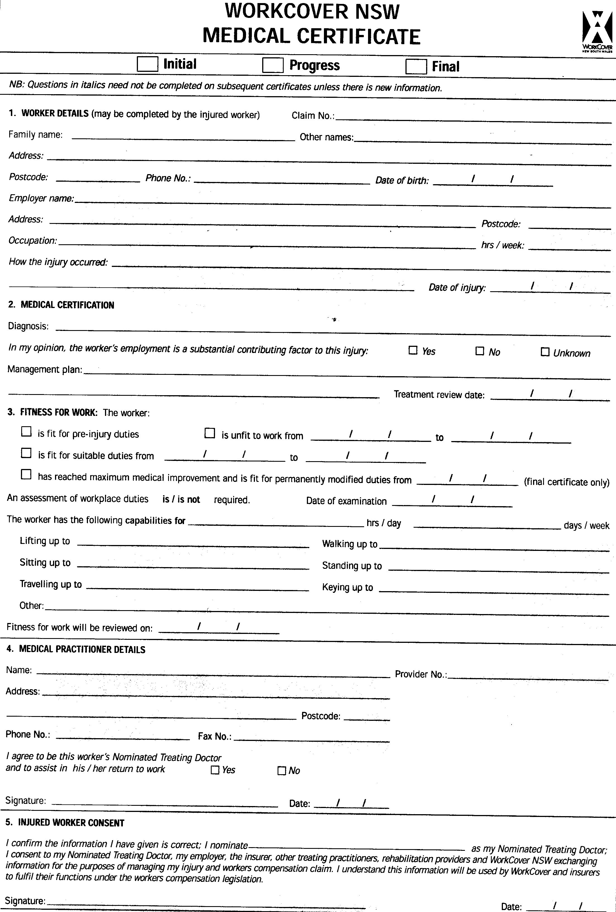

Filename: OHS Library\WorkCover Forms\MedicalCert.pdf
Filename for Notes to assist completing the WorkCover Medical Certificate –
OHS Library\WorkCover Forms\MedicalCert-Instructions.pdf

Total Insurance Workers Compensation (NSW) Limited
ABN 01 222 622 941
Tel: (02) 921 1101
Level 10, 999 Elizabeth Street, Sydney Fax: (02) 921 6147
Postal address: GPO Box 999-2, Sydney 2001 Email: claims@totalinsurance.com.au

Fax Form for Initial Notification of Injury
- Use this form to notify us if an employee suffers a work-related injury
- A claim form will then be forwarded to you for completion by the employee
- Please ensure that you supply as much information as you can. This will allow us to make payments and also to develop an injury management plan for the employee.

Employer Name |  | Policy No
Business Address
Workplace Address |  | Telephone
 |  | Fax
Contact Name
Contact Email
Name of Rehab Provider |  | Significant Injury? | □ Yes □ No

Worker’s Name |  | Sex | □ Male □ Female
Address |  | Date of Birth
 |  | Telephone
Telephone |  | Work Status | □ F/T □ P/T
Occupation |  | Hours/week
Main Tasks |  | Award Rate | $
Interpreter Req’d | □ No □ Yes – language

How did injury occur? |  | Date of injury
Details of injury |  | Time of injury
Name of treating doctor or hospital  (if admitted) |  | Telephone
Address of above |  | Fax

Medical Certificate from |  | Medical Certificate to |  | Incapacity | □ Total □ Partial
Date Ceased Work |  | Date Return to Work |  | Claim Lodged | □ Yes □ No
Date Return to Work – partial |  | Date return to work - normal

Comments

Injury Notified by (full name) |  | Tel
Relationship to Worker | □ Employee □ Employer □ Other – please specify

FOR OFFICE USE ONLY
□ Claim information sufficient? □ Medical information supplied? □ Is injury work related? □ Is worker status correct?
Have claim forms been posted? □ Yes □ No

Filename: HR Department\OHS\Forms\FaxClaim-Total Insurance.doc

NOTE: To obtain copies of Incident Report Forms - contact any local office of WorkCover, or,
telephone the WorkCover Publications Order Line on 1800 658 134

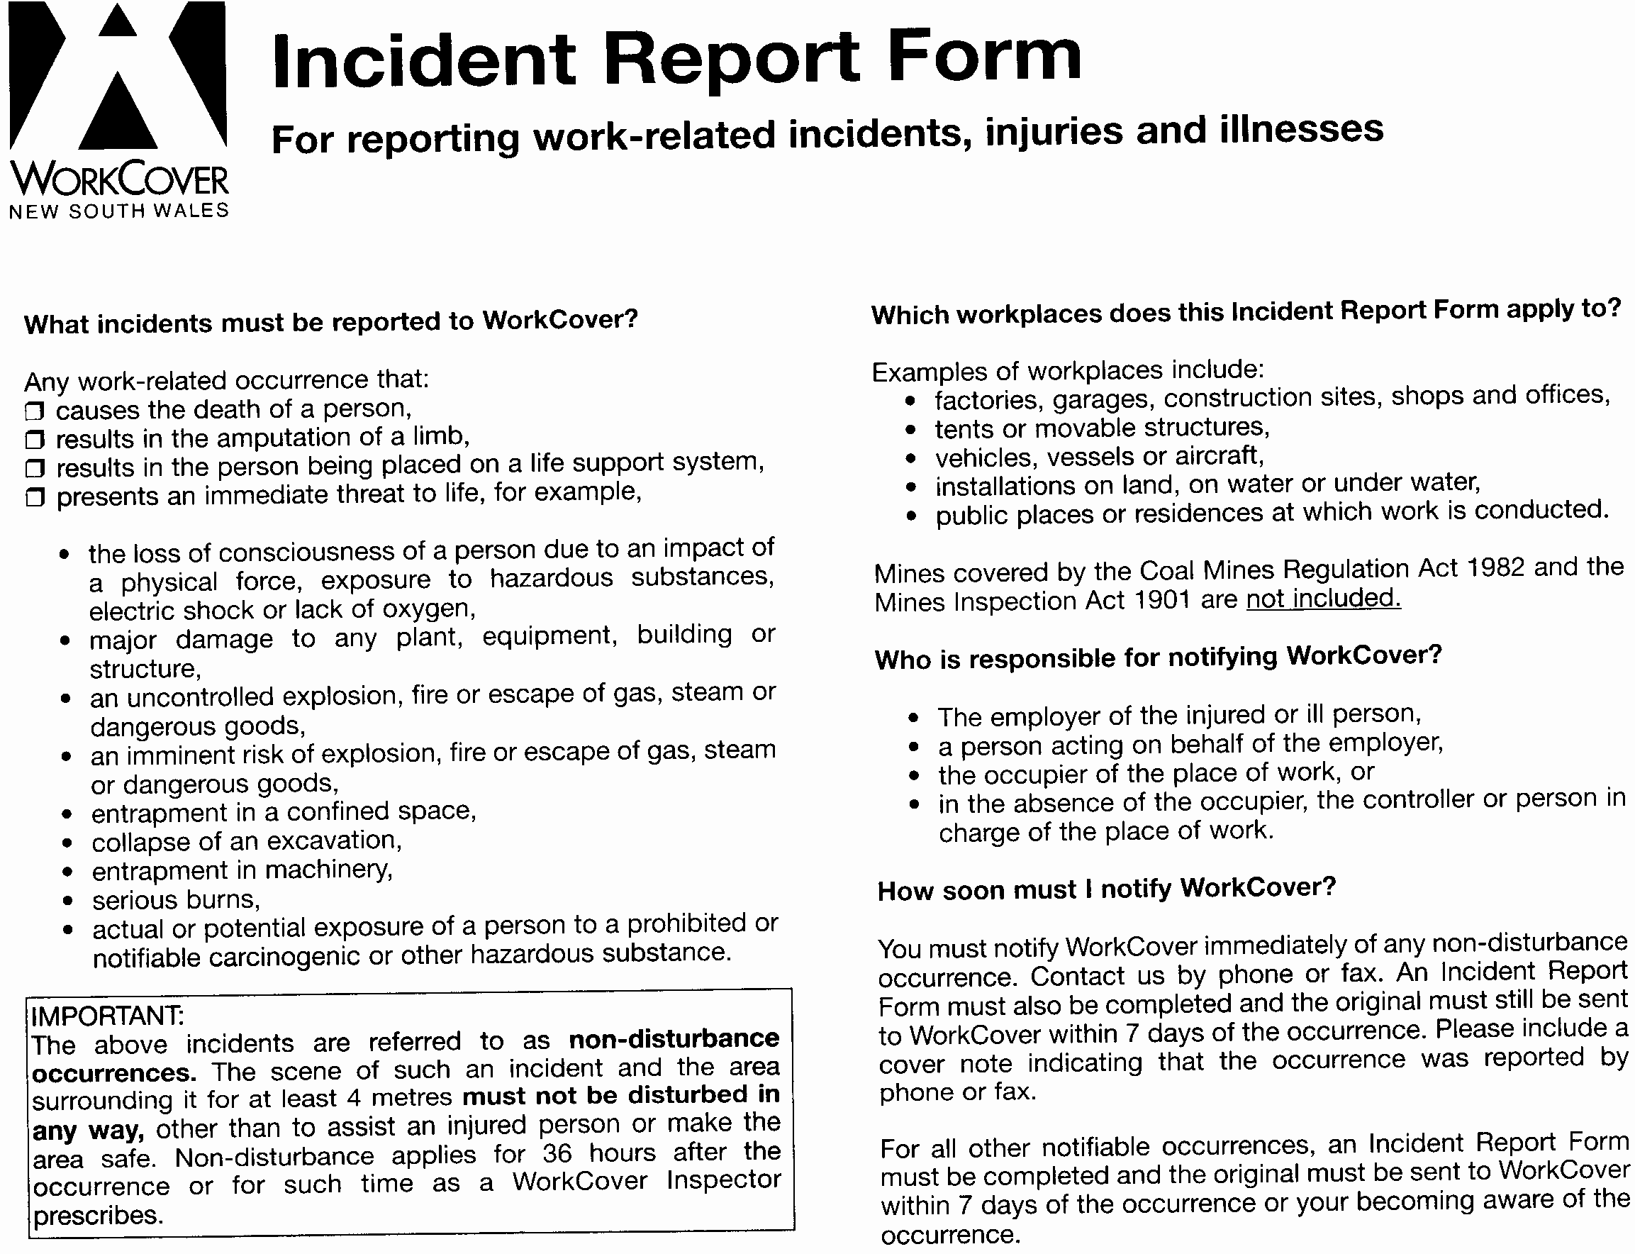

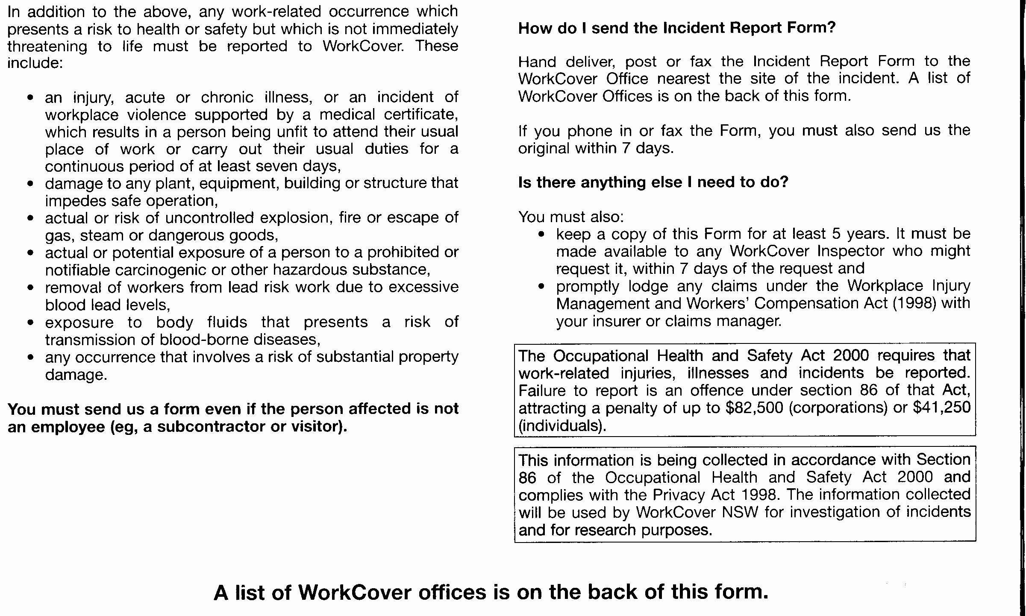

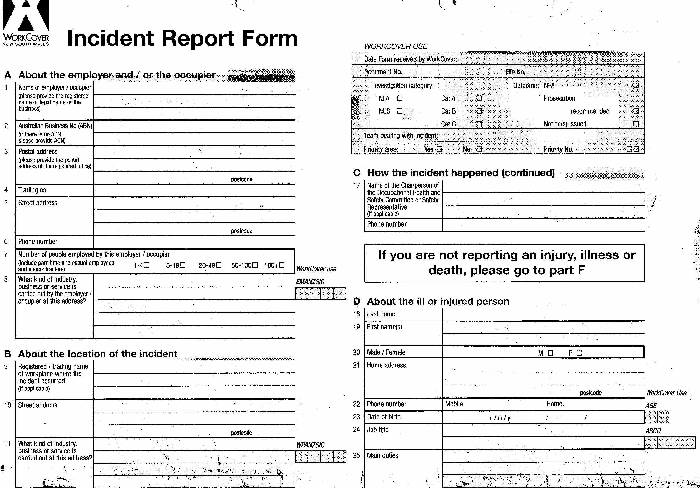
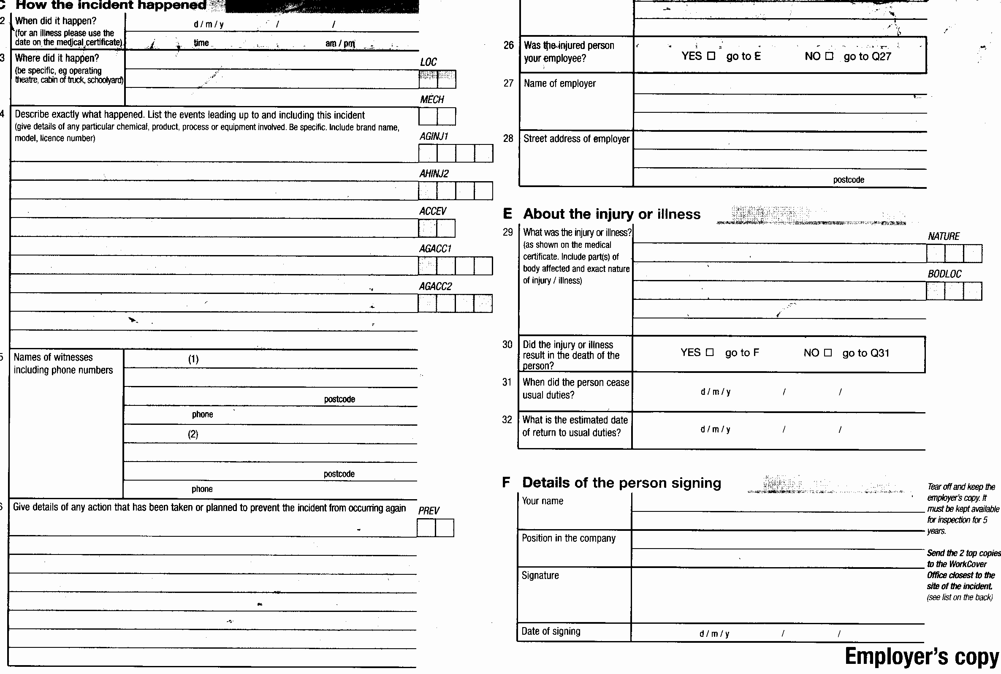

Workers Compensation

Under Section 231 of the Workplace Injury Management and Workers Compensation Act 1998, an employer is required to display a summary of the Workers Compensation Act and other information contained in the Workplace Injury Management and Workers Compensation Act 1998 conspicuously in the workplace so that it can be easily read by workers.

A poster of the prescribed summary is displayed in the Reception area. A copy of this poster is also shown on the following page.

Claiming Workers Compensation

From 1 January 2002, if you suffer a work-related injury, you will not in most cases need to submit a claim form to receive workers compensation. Weekly payments will normally commence within seven days of the insurance company, Total Insurance Workers Compensation (NSW) Limited, being notified of your injury. These payments are called provisional liability payments and can be made for up to 12 weeks and are designed to reduce the impact of injury and illness. In the same way, a claim for medical expenses compensation of up to $5000.00 may be accepted provisionally.

In the following cases, however, you will need to make a claim for workers compensation –

- if the insurance company asks you to make a claim
- if you require benefits that exceed your entitlements (ie weekly payments for more than 12 weeks, or medical expenses of more than $5000.00) under the new streamlined injury notifications/claims processing systems, or
- the insurance company has stopped making provisional payments and you consider that you are still entitled to more benefits

A copy of the WorkCover NSW Workers Compensation Claim Form is shown on pages 38-39. This form, together with guidelines for completing, can be accessed from the -OHS Library\WorkCover Forms folder.

 | WATCHING OUT FOR YOU  NOTE: This poster is to be displayed in the Reception Area.  You can access a copy of this poster from -  HR Department\OHS\Forms\WorkCoverPoster.pdf

A SAFE WORKPLACE  Your employer needs to:  - Identify workplace hazards  - Assess the risk of an injury  - Eliminate/control the risks – to solve the problem |  | Your employer has a legal obligation to keep your workplace safe.  If you have any health and safety concerns about the work you are doing, tell your employer before anyone gets hurt.
IF AN INJURY OCCURS  - Report the injury to your employer  - See a doctor and get a WorCover medical certificate  - Give the certificate to your employer  - Ask your employer to contact their insurance company  (or contact the insurance company directly) |  | Keep a copy of all documents relating to your injury. In some cases, your employer’s insurance company may require you to submit a workers compensation claim form.
WHAT YOU SHOULD EXPECT  While getting better:  - Keep in contact with your employer and your employer’s insurance company  - Payments commence, in most cases, within seven days of your injury being notified to your employer’s insurance company  - Medical costs relating to your injury are paid |  | A significant injury prevents you from undertaking your normal duties for more than seven days. If you have a significant injury, your employer’s insurance company must contact you, your employer and doctor within three days to set up a plan to help you get back to work.
RETURN TO WORK  If you’re going to be off work for more than a few days:  - Ask your doctor and employer about suitable duties  - Participate in the plan to help you get back to work |  | If you cannot do all your normal duties, your employer should give you suitable duties. Talk with your doctor about whether there are at least some work duties that you can continue to do. Sometimes, a gradual return to work is advisable. Make all reasonable efforts to return to work as soon as possible.
IF THERE IS A PROBLEM  - Talk to your employer and your employer’s insurance company  - The WorkCover Assistance Service helps you navigate the workers compensation system  - The Workers Compensation Commission helps you resolve disputes  - You can be represented by your union or your lawyer |  | The WorkCover Assistance Service provides help and advice to you and your employer regarding workers compensation. The Workers Compensation Commission is approachable and accessible and ensures that disputes are resolved in a timely, fair manner.  Note: There are severe penalties for false or fraudulent claims.
For further information phone the WorkCover Assistance Service on 13 10 50.
The return-to-work coordinator for this workplace is: Your employer’s workers compensation insurer is:
Lyn Singh, Human Resources Manager Total Insurance Workers Compensation (NSW) Limited

Disclaimer: This is a simplified explanation of the Workers Compensation Act 1987 and the Workplace Injury Management and Workers Compensation Act 1998, and is valid only in NSW

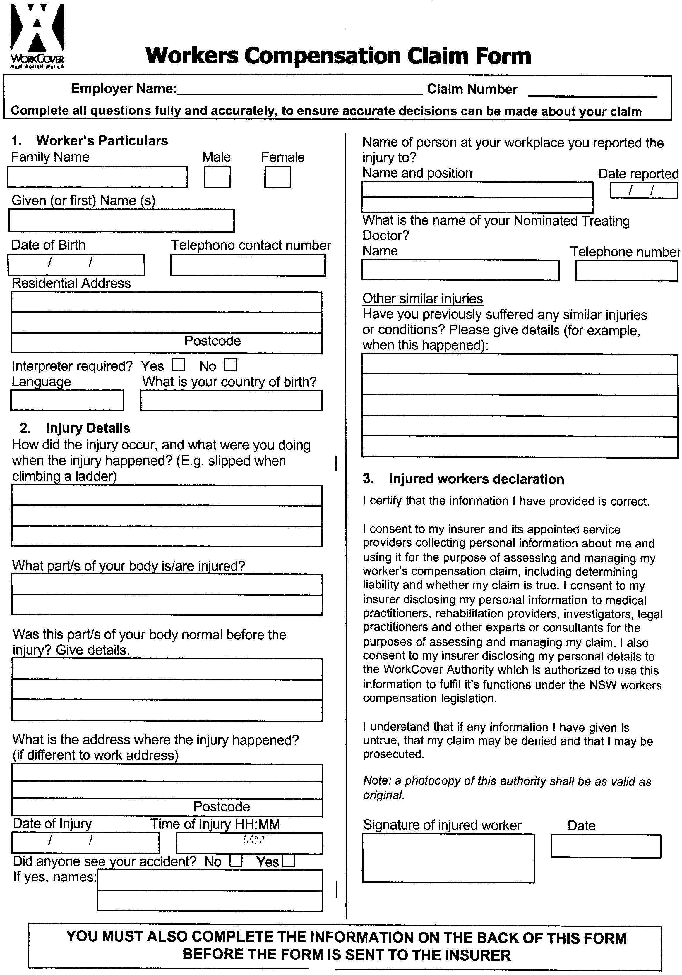
[Page 1 of 2]
Filename: OHS Library\WorkCover Forms\WorkersCompClaimForm.pdf
Filename for WorkCover Provisional Liability and Claims Guidelines –
OHS Library\WorkCover Forms\WorkersCompClaimForm-Guidelines.pdf

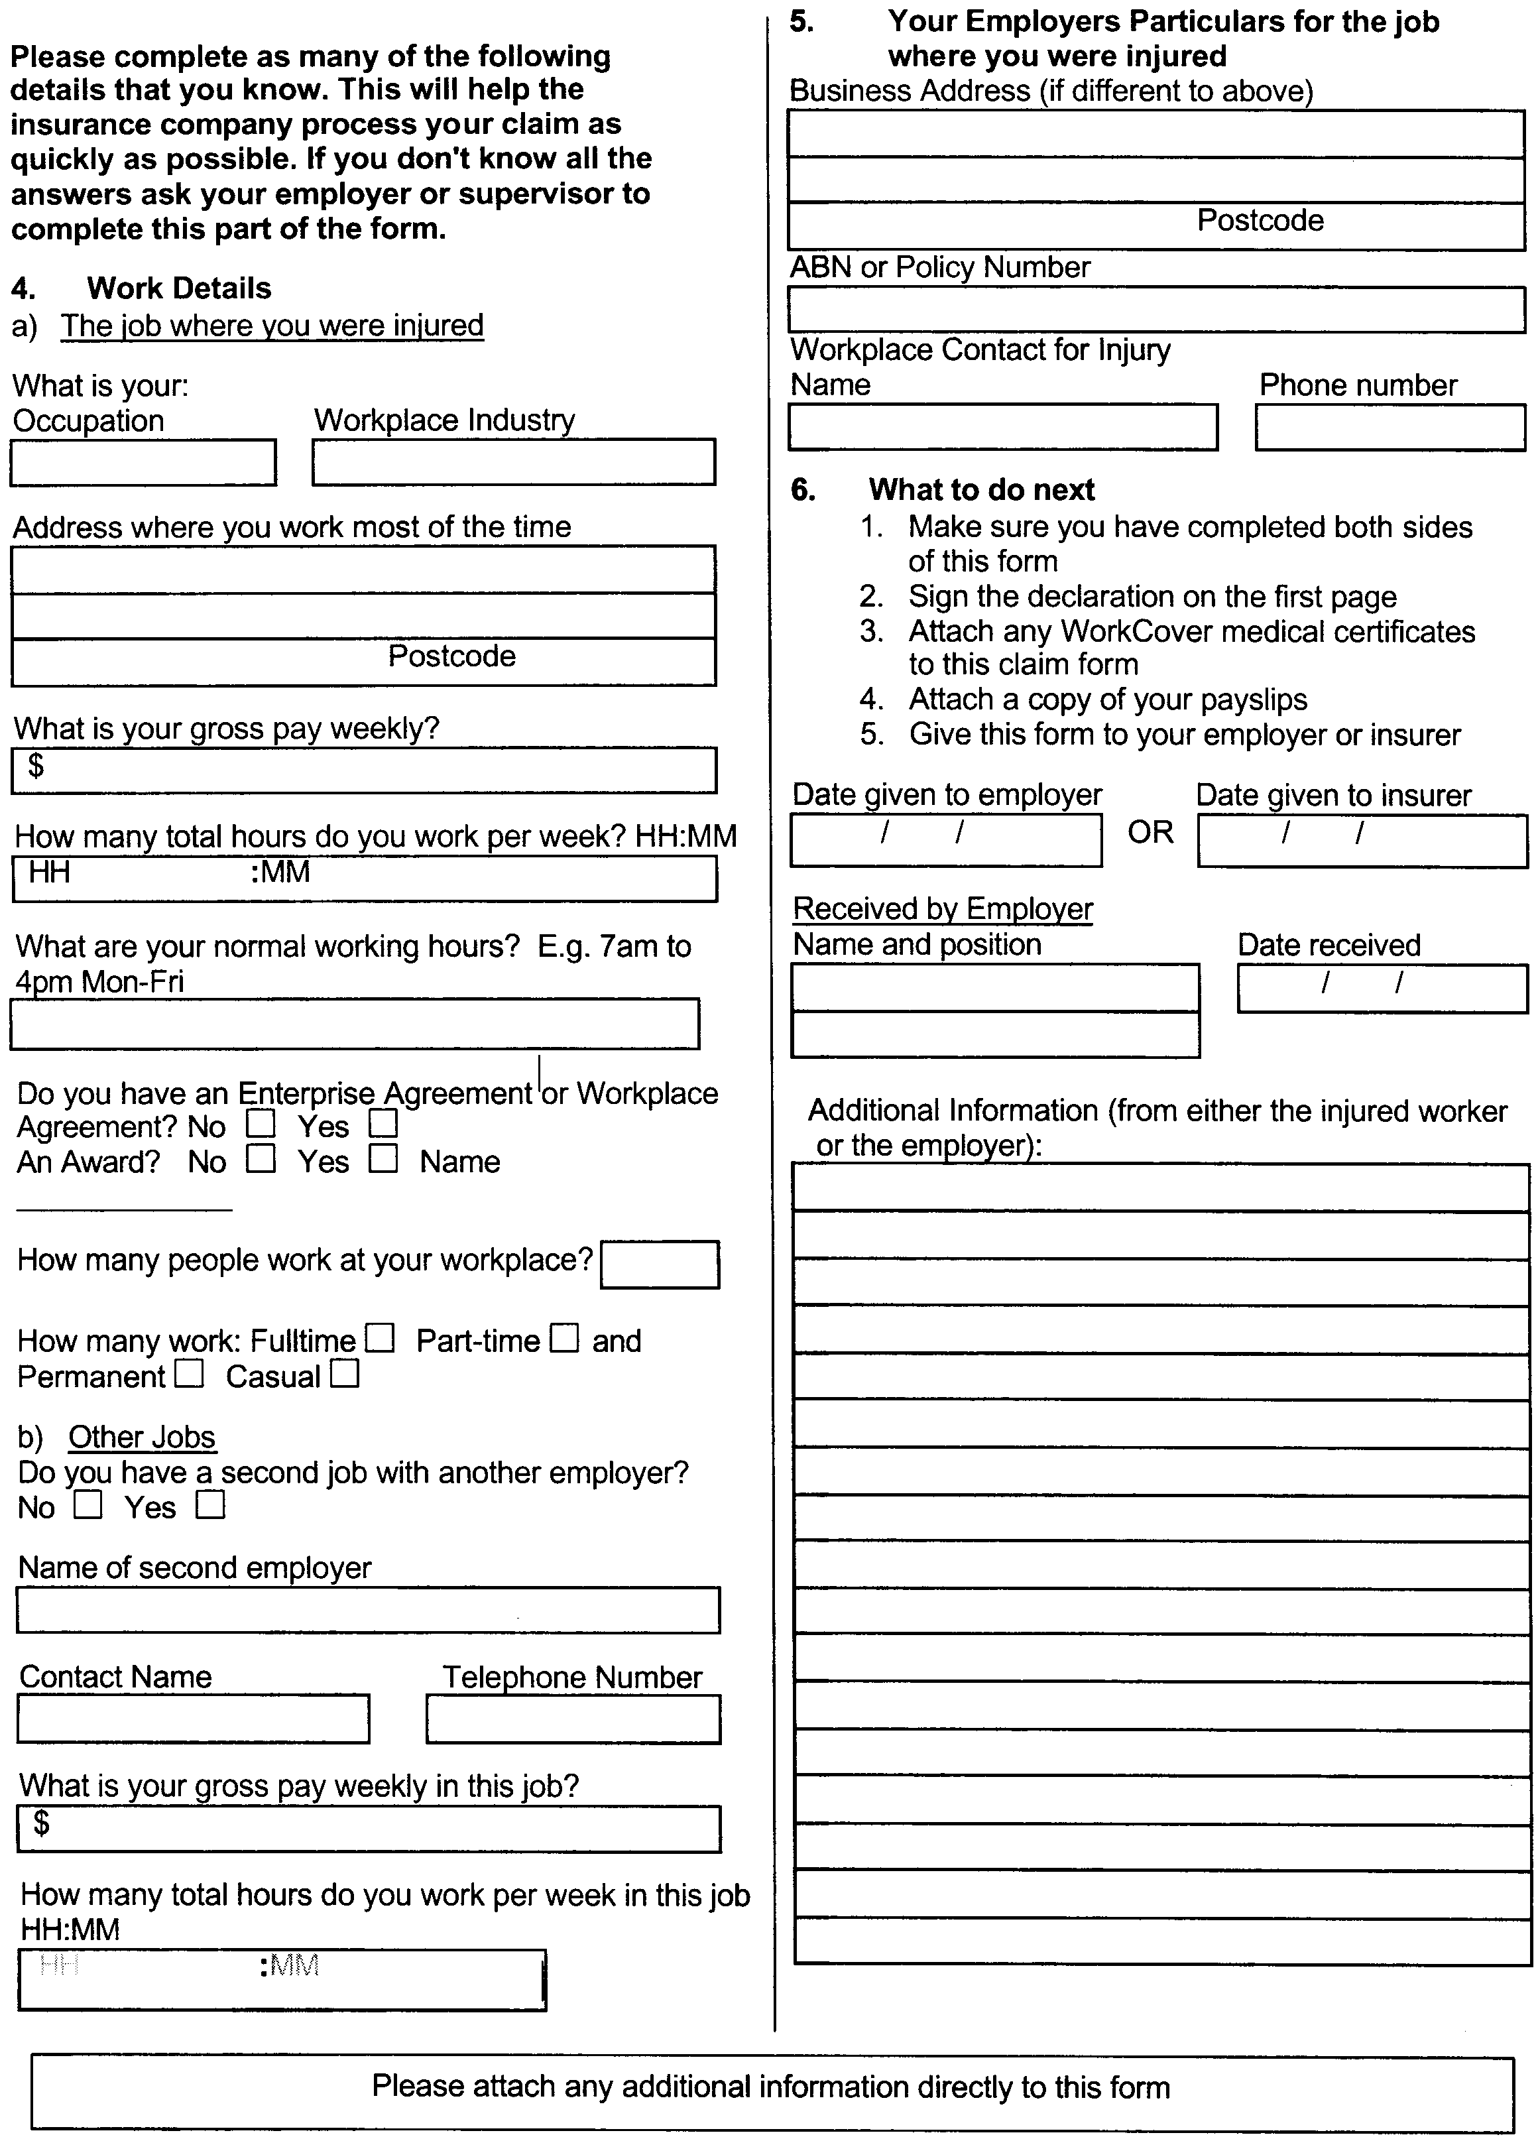
[Page 2 of 2]

Return to Work Program

The Workplace Injury Management and Workers Compensation Act 1998 and associated Regulation requires that an effective Return to Work Program is in place to ensure that if you are injured in the workplace, you will receive swift attention and an early return to work.

Swaggies Pty Ltd undertakes to ensure that the duties offered to you, as part of your Return to Work Program, will always be meaningful, productive and a safe match with your physical and psychological capabilities and consistent with medical advice.

Injury notification
- If you are injured, you must notify your manager that you have received an injury as soon as possible after the event occurred – refer to Step 1, Hazard, Incident and Injury Reporting Procedures on page 20.
- The HR Manager will notify our insurer, Total Insurance Workers Compensation (NSW) Limited, within 48 hours after becoming aware that you have received a workplace injury that seems to be a significant injury.
A ‘significant injury’ is one that prevents you from undertaking your normal job for more than seven days.
For injuries other than a significant injury, we will notify our insurer within 7 days after becoming aware that you have received an injury.

Your obligations
If you are injured, you must –
- participate and cooperate in the establishment of the Injury Management (IM) plan
- comply with your obligations under the IM plan
- nominate a treating doctor who will agree to participate in the development of the IM plan
- authorise the treating doctor to provide relevant information to our insurer, Total Insurance Workers Compensation (NSW) Limited, or to us for the purposes of the IM plan
- make all reasonable efforts to return to work as soon as possible, having regard to the injury.

Our obligations
- We will participate and cooperate in the establishment of the IM plan and comply with the obligations imposed upon us under the IM plan
- We will provide suitable employment for you upon your return to work, either on a full-time or part-time basis. A return to work plan will be developed by the Return to Work Coordinator after discussions with you and the treating doctor.

Our insurance company must then -
- establish an injury management plan in consultation with our Return to Work Coordinator, the doctor and yourself
- provide information regarding the IM plan to both you and the Return to Work Coordinator
- keep the Return to Work Coordinator informed of significant steps taken, or proposed to be taken, under the IM plan

Return to Work Program (con’td)

The nominated treating doctor -
- must provide a WorkCover Medical Certificate (refer page 30)
- is the point of communication for treatment and the IM plan
- will be authorised by you to provide information to Swaggies and the insurance company relating to the nature of your injury, extent of incapacity, any restrictions on employment prognosis, suitable duties and timeframes for a return to suitable work.

The injury management consultant
- Any difficulties in relation to the suitability of duties offered to you can be referred to an injury management consultant. The ‘injury management consultant’ is a medical practitioner appointed by WorkCover to facilitate agreement between you, Swaggies and your treating doctor, about the suitability of duties.

The publication, WorkCover Guidelines for Employer’s Return-to-Work Programs, can be accessed from the OHS Library folder – filename rtw_guide.pdf

Procedures - Return to Work Program
for Injured Workers

The following general procedures have been established by Swaggies Pty Ltd to ensure the safe and speedy return to work of injured employees.

- When an Injury Occurs
  - All injuries must be notified and reported on immediately in accordance with the company’s Workers Compensation Procedures.
  - The importance of the legal requirements to notify Total Insurance Workers Compensation (NSW) Limited, the company’s workers compensation insurers of the injury, within the stated timeframes is re-emphasised.
  - The Human Resources Manager will be responsible for coordinating all efforts aimed at assisting the injured worker recover and return to work as quickly and as safely as possible.
  - For all lost time injuries, the Human Resources Manager will contact the injured employee within 24 hours of the injury being reported to ensure –
    - that appropriate medical attention is received
    - that the process of lodging a Workers Compensation Claim is explained and
    - to prepare the injured employee for a safe and timely return to work consistent with medical advice

- Nominating a Treating Doctor
  - All injured employees MUST nominate a treating doctor who will be responsible for medical management of the injury and will cooperate with the development and implementation of the Return to Work program.
  - Provision for nominating the treating doctor is made on the approved WorkCover Medical Certificate.

- Involving a Rehabilitation Provider
When it becomes evident that an injured employee is not likely to resume their pre-injury duties or cannot do so without changes to the workplace or the work practices, the Human Resources Manager will consult Total Insurance Workers Compensation (NSW) Limited, the company’s workers compensation insurers, and the worker’s treating doctor to discuss the need to involve an accredited Rehabilitation Provider to assist develop and monitor the Return to Work Plan.

Accredited Rehabilitation Providers to be used when required are –

A1 Rehab Management Centre
M W Occupational Health Services Pty Ltd

The company acknowledges, however, that the injured employee has the right to choose his/her treating doctor and rehabilitation provider. Should an employee wish to change doctor or provider, he/she must contact the insurer.

- Finding and Providing Suitable Duties
The Human Resources Manager in consultation with the treating doctor will ensure that individual return to work strategies are developed for each injured worker.

This will include provision of suitable duties for those workers who are partially incapacitated and therefore need to be offered suitable duties as part of their rehabilitation program.

The company undertakes to ensure that the duties offered to injured employees as part of their Return to Work program will always be meaningful, productive, a safe match with the client’s physical and psychological capabilities and consistent with medical advice.

- Consultation
The Human Resources Manager will consult injured worker, doctor, insurer and co-worker(s) regarding the implementation of any arrangements for the return of work of injured employees of the company.

- Disputes
The Human Resources Manager will attempt to resolve any disputes by consulting with employees, the Rehabilitation Provider and the treating doctor. If the dispute cannot be resolved, the insurer will be contacted for advice.

Endorsement
These policies and procedures will come into effect as of 15 January 2002 and may be reviewed and amended by the agreement of the undersigned or their representatives –

Signed: |  | Signed:
Employer’s Representative |  | Employee’s Representative

Date: | 15 January 2002 | Date: | 15 January 2002

Filename: HR Department\OHS\Forms\ReturnToWorkProgram-Procedures.doc
Checklist for
Managing the Return to Work Plan

Employee’s Name |  | Claim Number
Date of Injury |  | Date Claim Made

Have we forwarded the following information to Total Insurance Workers Compensation (NSW) Limited?
 |  | Date Submitted |  | Notes
□ | The Fax Form for Initial Notification of Injury
□ | The completed claim form
□ | The employer’s report of injury
□ | Any witness reports
□ | WorkCover medical certificate
□ | Wage details and lost time details
□ | Other information which will assist the determination of the claim

Have we received the following information from Total Insurance Workers Compensation (NSW) Limited?
 |  | Date Submitted |  | Notes
□ | Contact by Total Insurance re Injury Management Plan (within 3 days)
□ | An Injury Management Plan received
□ | Notification of liability status received
□ | Notification of weekly amount of compensation received
□ | Notification of any medical assessments received

Contact Details
Contact | Contact No | Date | Notes
□ Injured Person
□ Treating Doctor
Name:
□ Others (eg Physio)
Name:
Name:
Name:

Filename: HR Department\OHS\Forms\ReturnToWorkPlan-Managing.doc
Return to Work Plan
NB: A Return to Work Plan MUST be developed prior to the injured person returning to work on restrictions. Each time the person is reviewed and the restrictions and/or duties change, a new Plan must be prepared.

□ | Initial RTW Plan | □ | Progress RTW Plan
□ | Goal – Same job same employer | □ | Goal – Same job different employer
□ | Goal –Different job same employer | □ | Goal – Different job different employer

Job Title
Work Location
Manager
Claim Number
Injury
Suitable duties

Considerations/Restrictions

Specific duties to be avoided

Hours/days of work
Wages (including make-up pay where applicable)
Commencement date
Review date/s
Length of program
Services/Treatment Required
(ie Physiotherapy)

Return to Work Plan (cont’d)

 | General Comments | (include the purpose of suitable duties, any treatment arrangements)

The following parties have agreed to the program:
 | Name | Date
Injured Worker
Manager
RTW Coordinator
Nominated Treating Doctor

The responsibilities of each of the above parties are outlined as:
Injured Worker | To cooperate with the Rehabilitation process and to notify Supervisor of any problems.
Supervisor | To ensure that the injured worker performs only the duties outlined above, monitors the injured workers ability to perform these duties, notifies Rehabilitation Coordinator of problems and to facilitate injured workers attendance at necessary services.
RTW Coordinator | To ensure all parties endorse the Return to Work Plan, monitor the injured workers progress, coordinate services to solve problems, change duties as required or medically endorsed.
Nominated Treating Doctor | To manage treatment of the injured/ill employee including participation in the Injury Management Plan. Provide medical advice and certification according to State legislation.

Filename: HR Department\OHS\Forms\ReturnToWorkPlan.doc

OHS Induction Training Program

The aim of the OHS Induction Training Program is to make our workplace safer and more productive.

The induction process involves the following key people

- the new employee’s Manager
- the Health and Safety Representative
- co-workers in the department.

Guide to conducting the induction
- Pace the induction so that the new employee is not overwhelmed with too much information
- Give the new employee clear instructions and ask them to repeat those instructions
- Show and/or demonstrate to the new employee how to perform tasks. Emphasise the main points.
- Encourage the new employee to ask questions
- Don’t assume any prior knowledge, training or experience. Be prepared to go over things that may seem ‘common sense’ despite the new employee’s background.
- Consider the language, cultural and literacy needs of the new employee.
- Until they are competent, ensure that the new employee is supervised while they perform their work tasks. Correct any mistakes immediately.
- Check that the new employee has understood what they have been told and shown.
- Follow-up with frequent visits, talks and training sessions as required through the new employee’s first year.

Filename: HR Department\Induction\Guide to OHS Induction.doc

Induction Checklist for New Employees

Employee’s Name |  | Job Title
Employment Start Date |  | Name of Manager

Introduction  (Explain to your new employee about …)  - The industry, nature and structure of your business  - Roles of key people in your business, job, tasks, and responsibilities | Other Requirements  (Explain to and show your new employee about …)  - Quality procedures  - Security issues  - Facilities
Job Introduction  - Demonstrate to the employee how to do the job safely  - Provide required information  - Introduce other employees and their managers  - Introduce the first aid officer and show location of first aid supplies  - Explain and demonstrate emergency procedures  - Show location of exits and fire equipment  - Show the work area, toilet, drinking water and lunchroom facilities  - Show how to safely use machinery, equipment and hazardous substances  - Show where to locate copy of Policy and Procedures Manual | Health and Safety  (Explain to your new employee about …)  - Health and Safety policy and safe working procedures  - Roles and responsibilities of people in the OHS Committee  - Hazards in the workplace and how they are controlled  - How to report health and safety issues (including forms)  - How they will be kept informed about health and safety issues  - Workers compensation claims
Employment Conditions  (Explain to your new employee about …)  - Work times and meal breaks  - Rates of pay and how payment is made  - Taxation (including filling out required forms)  - Superannuation and other deductions  - Leave entitlements  - Notification of sick leave or absences | Conducted by  Name  Signature  Date  Employee’s Signature  Date

Filename: HR Department\Induction\InductionChecklist.doc

OHS Training Programs

In order to implement the general provisions of the Health and Safety Policy, Swaggies Pty Ltd will develop, implement and review OHS training programs for management and employees.

Training programs will relate to all aspects of occupational health and safety, including –

- OHS induction training
- OHS staff training and education
- work design, workplace design and standard work methods
- changes to work methods and practice, including those associated with technological change
- safety rules, including penalties
- emergency procedures
- provision of OHS equipment, services and facilities
- workplace inspections and evaluations
- reporting and recording of incidents, accidents, injuries and illnesses and provision of information to employees

OHS Training Program

Training Strategy 2002-2003

Strategy

To identify the health and safety training needs of all Head Office and Warehouse personnel.

Individual employees require specific competencies to undertake tasks safely. As part of our OHS Training Program, we will determine the various task competencies and examine what additional training is needed for individual employees to meet those competencies.

The assessment of hazards should identify the requirements for specific training of employees.

Action Required

- Develop and maintain records of hazard identification, risk assessment and control
- Identify skills/competencies required for individual job descriptions
- Perform a training needs analysis
- Develop a task skills matrix showing individual competencies and further training needs
- Identify and develop personal development plans for individual employees

Responsibility of

- Human Resources Manager
- Occupational Health and Safety Officer

OHS Training Program

Management Training Strategy 2002-2003

Strategy

To provide training to Senior Management which includes explanation of legal obligations and health and safety management principles and practices.

Senior management must be aware of their legal obligations for health and safety and have an understanding of how to go about meeting these obligations. As part of our OHS Training Program, we will provide senior management with this knowledge and equip them to improve their management skills in this area.

Action Required

- Identify suitable formal education programs
- Document content of training courses
- Develop additional instruction/guidance material
- Identify reporting procedure to monitor training outcomes
- Maintain training records in accordance with procedures

Responsibility of

- Human Resources Manager
- Occupational Health and Safety Officer

OHS Training Program

Manager Training Strategy 2002-2003

Strategy

To provide training to all Managers appropriate to their role and responsibilities.

The company must provide the information, instruction, training and supervision necessary for employees to work safely and without risk to their health. Managers are required to understand the hazards and the implementation of the control measures adopted by the company.

Managers must be fully aware of their health and safety obligations under the relevant legislation, and they should also have sufficient knowledge to ensure that employees perform their work safely, that hazard control measures function correctly and that potential hazards are recognised.

Action Required

- Identify training needs for individual managers
- Identify/locate suitable training programs
- Document content of training programs
- Maintain training records in accordance with procedures

Responsibility of

- Human Resources Manager
- Occupational Health and Safety Officer

OHS Training Program

Employee Training Strategy 2002-2003

Strategy

To provide training to all Head Office and Warehouse employees to enable them to perform their tasks without risk to their health and safety

All employees should have the competencies required to undertake their tasks safely. As part of our OHS Training Program, job-specific safety training together with safe working procedures will be provided to all employees. Records of employee training will be maintained by the HR Department.

Action Required

- Develop job-specific training programs for office and warehouse personnel
- Maintain training records to show that all employees have had job-specific health and safety training
- Prepare documentation to show the content of training
- Record results of risk assessment in accordance with National Safety Regulations (eg manual handing, hazardous substances, confined spaces etc)

Responsibility of

- Human Resources Manager
- Occupational Health and Safety Officer

Sources for further reference

The following information is available from the OHS Library folder –
Folder Name | Publication | Filename
NSW Act-Regulation | OHS Act  Summary of the OHS Act  OHS Regulation 2001  Summary of the OHS Regulation 2001 | OHSAct-2000.pdf  OHSAct-2000Summary.pdf  OHSRegulation-2001.pdf  OHSRegulation-2001-Summary.pdf
Codes of Practice | WorkCover NSW  Code of Practice for the Control of Workplace Hazardous Substances  Code of Practice for Noise Management and Protection of Hearing at Work  OHS Consultation, Code of Practice 2001  Risk Assessment, Code of Practice 2001  Workplace Amenities, Code of Practice 2001  WorkCover Victoria  Code of Practice for Manual Handling, 2000 | cop_control_hazsub.pdf  cop_noise.pdf  cop_ohsconsultation.pdf  cop_riskassessment.pdf  cop_WorkplaceAmenities.pdf  cop_VWA Manual Handling.pdf
OHS Committees | A Guide to Workplace Health & Safety Committees, WorkCover NSW, Aug 1998  Participating in Effective OHS Committees: A Guide for Committee Members, Comcare Australia, 1999 | Guide-OHSCommittees.pdf  Participating-OHSCommittees.pdf
Risk Management | Risk Management at Work, Guide 2001, WorkCover NSW | RiskMgmentAtWork.pdf
First Aid | First Aid in the Workplace | First Aid in the Workplace.pdf
Office Safety | Health and Safety in the Office, WorkCover Authority  Officewise – A guide to health and safety in the office, WorkSafe, Victoria, 4th ed, 2001 | OfficeHealth&Safety.pdf  Officewise_v2.pdf
Publications | Due Diligence at Work, WorkCover NSW  General Safety Rules Handbook  When an Inspector Calls, Guide 2002, WorkCover NSW  Six Steps to Occupational Health & Safety  WorkCover NSW Guidelines for Employer’s Return-to-Work Programs  WorkCover NSW Small Business Safety Starter Kit, Guide 2001,  WorkCover NSW Workplace Safety Kit, Guide 2001, Workcover, NSW | DueDiligence.pdf  General Safety Rules Handbook.pdf  Inspector_Calls.pdf  SixStepsToOHS.pdf  rtw_guide.pdf  SmallBusStarterKit.pdf  WrkplaceSafetyKit.pdf
WorkCover Forms | WorkCover Medical Certificate  Notes to assist completing the Work Cover Medical Certificate  WorkCover Workers Compensation Claim Form  WorkCover Provisional Liability and Claims Guidelines | MedicalCert.pdf  MedicalCert-Instructions.pdf  WorkersCompClaimForm.pdf  WorkersCompClaimForm-Guidelines.pdf

Sources for further reference (cont’d)

Internet Websites

NOHSC
National Occupational Health and Safety Commission (NOHSC) | http://www.nohsc.gov.au
The National Occupational Health and Safety Commission is a tripartite statutory body, with government, employer and employee representatives.

NSW
WorkCover NSW | http://www.workcover.nsw.gov.au
WorkCover NSW manages the State's workplace safety, injury management, and workers compensation systems.

Workers Compensation Commission | http://www.wcc.nsw.gov.au
The Workers Compensation Commission is an independent and impartial statutory tribunal for disputed workers compensation claims in New South Wales. It was established by the Workplace Injury Management and Workers Compensation Act 1998.

NSW Health Department | http://www.health.nsw.gov.au/

Australian Commonwealth Government
Comcare | http://www.comcare.gov.au
Comcare Virtual Office | http://www.comcare.gov.au/virtual_office/introduction.html
Comcare is the workers' compensation insurer for the Australian Commonwealth Government, providing safety, rehabilitation and compensation services to Commonwealth employees (and employees of the ACT Government) under the auspices of the Safety, Rehabilitation and Compensation Commission.

Victoria
Victorian WorkCover Authority | http://www.workcover.vic.gov.au

South Australia
WorkCover Corporation of South Australia | http://www.workcover.com

Tasmania
Tasmanian Workplace Standards Authority | http://www.wsa.tas.gov.au/

Other
Standards Australia | http://www.standards.com.au

Useful OHS Links and Sites | http://www.ohs.com.au/sites.htm

