Preparing a Budget

A reference and resource document



TABLE OF CONTENTS

Definition 1
The budgeting process 1
Purpose of budgets 1
Benefits of budgeting 1
Limitations of budgeting 2
Preparing budgets 2
Steps in budgetary control 4
The contents of a budget 5

Definition
A budget is a written document that outlines the prediction of costs over a set period. It can be described as a detailed plan (usually expressed in monetary terms) outlining anticipated financial outcomes resulting from the implementation of management strategies.

The budgeting process
Budgeting is the entire process of developing and implementing a plan for an organisation’s activities and reviewing the actual performance against the organisation’s budgets. The activities involved in budgeting include:
- Estimating and forecasting
- Planning
- Preparation of the budget documents
- Distribution of budget documents and implementing the budget
- Review of budget expectations against actual performance.

Purpose of budgets
The purpose of individual budgets will depend on the organisation and how it is structured, and could include:
- Ensuring a detailed short-term plan is prepared
- Encouraging teamwork within the relative sections, resulting in improved communication
- Providing formal allocation of resources
- Establishing benchmarks for actual results
- Allocating specific tasks and areas of responsibility to ensure accountability and improving motivation.

Benefits of budgeting
The level of benefit gained will be linked to how well the budgeting process has been designed and met. By implementing a budget, management will be forced to plan in order to meet the budgetary requirements. The increased level of control and implementation of standards provide a future map for the organisation. Involving staff in the total process often serves to bind members in pursuit of a common goal and increase workplace morale.

Limitations of budgeting
A budget is only as good as the information or estimates on which is has been formulated. It is not a guarantee of success. For the goals to be met, timelines and targets should be realistic and achievable. Budget contents should be flexible and able to be changed if necessary. Contingency plans must be prepared in the event of problems occurring.

Preparing budgets
When preparing budgets common practice is to either work off historical data that is amended based on anticipated change in the relevant environment, or to adopt a zero-based approach where the organisation determines resource levels and measurable targets to be used as benchmarks.

The method used to prepare the budget contents may be qualitative or quantitative.

Qualitative methods are based on the opinion or judgement of relative staff and manager, who may rely on previous years’ activities to predict future outcomes. This method could be useful when a new product is being launched and there is no previous data to rely on to predict future results.

Quantitative methods rely more on mathematical forecasts and the use of spreadsheet programmes can be of great use here. By predicting changes over time and factoring in the relevant formulae, the spreadsheet will perform all the calculations and deliver the completed budget document.

Examples of such spreadsheet budgets are shown on the following page.

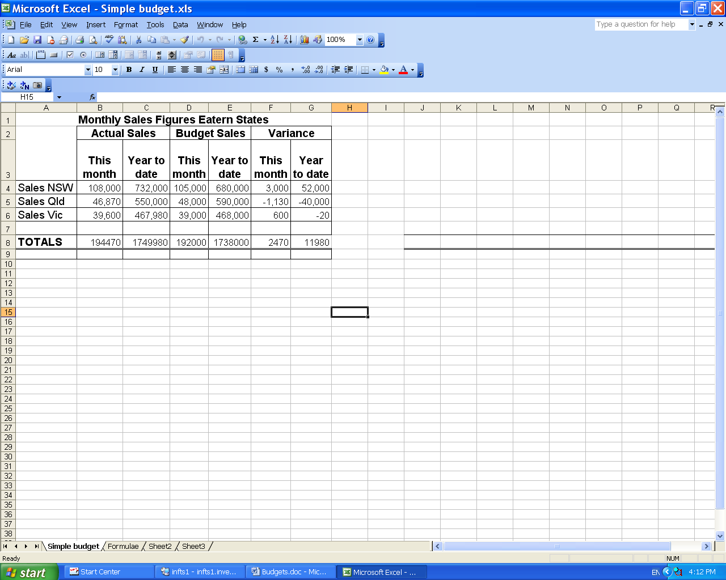
Figure 1 - Simple Budget spreadsheet

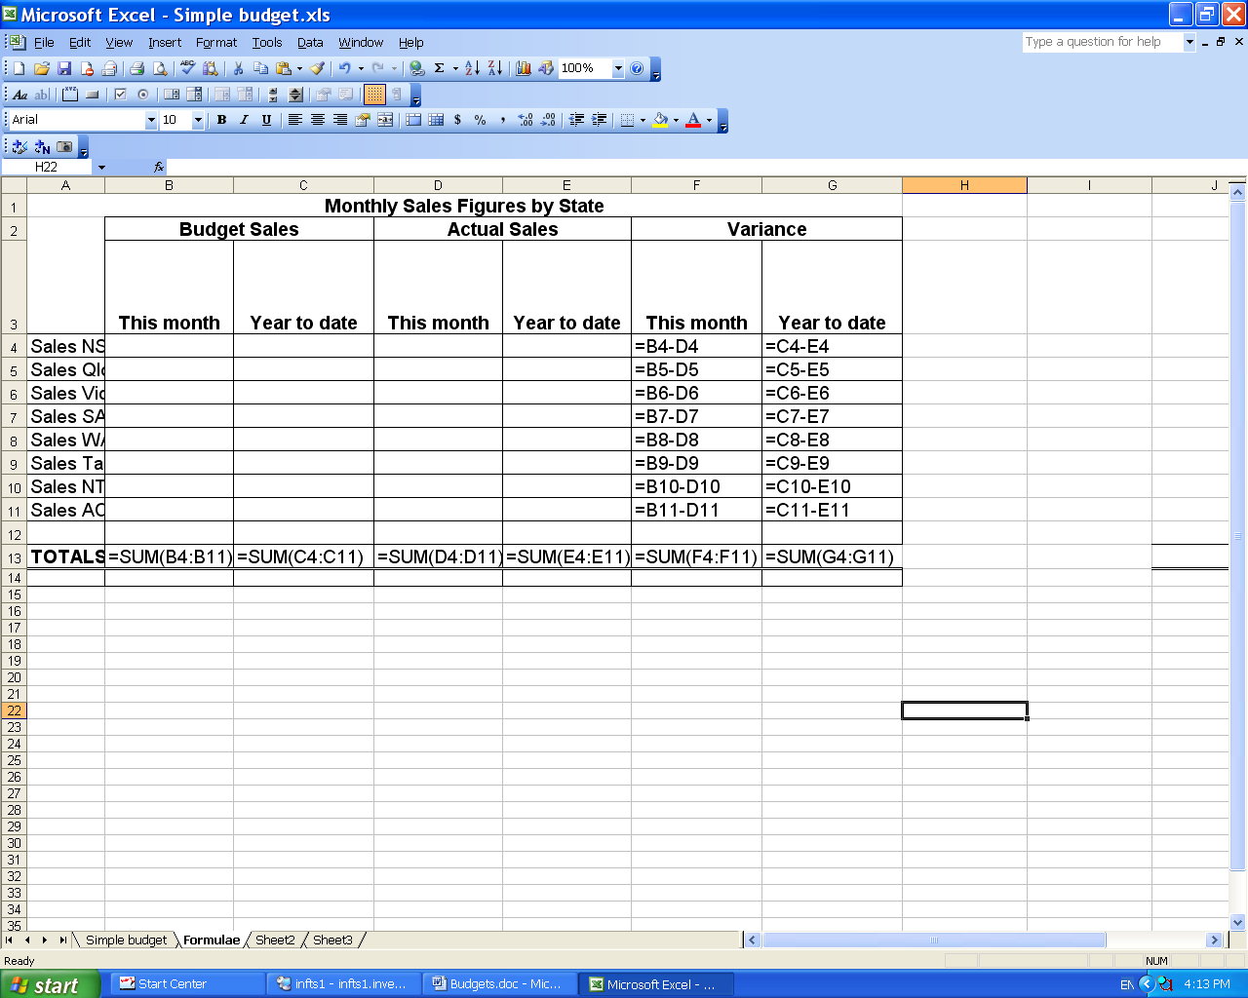
Figure 2 - Simple Budget spreadsheet showing formulae
Steps in budgetary control

Step One | Prepare relevant budgets
Step Two | Record and report actual results
Step Three | Compare actual results with corresponding budget estimates for the same period
Step Four | Calculate unfavourable variances
Step Five | Find reasons for each unfavourable variance
Step Six | Undertake corrective actions

To be an effective management tool, the budget process must include timely performance reporting. This consists of a comparison of actual results against expected targets (the budget) at pre-determined points in time, resulting in a report containing the variance between actual results and budget expectations.

This variance report is an evaluation of performance at that date. Variances can be either favourable (F) or unfavourable (U). Where a variance is favourable, the result achieved is better than anticipated, which is a positive result for the organisation. However, if the variance is unfavourable, the result is less than what had been expected, and is a negative result.

If we were budgeting for income and expenditure, the following would be an interpretation of results:

Variance situation | Interpretation of variance
Budgeted income is greater than actual income | The variance is unfavourable (U)
Budgeted income is less than actual income | The variance is favourable (F)
Budgeted expense is greater than actual expense | The variance is favourable (F)

Unfavourable results need to be identified and investigated. If the budgetary process is effective, this will occur promptly allowing corrective action to be taken.

The contents of a budget
How a budget is structured will depend on its purpose. A sales budget could include sales by product, sales by period, sales by region/area, or a combination of any of these. The contents could be represented in both quantitative and financial. A financial budget would usually contain income and expenditure recorded for set periods of time.

The main thing to remember is that the budget should reflect both the desired outcomes and the actual outcomes, and the difference between them at any given point.

Let’s look at how you might prepare a budget for a specific event such as a sales meeting.

- Identify all areas of expenditure (eg travel, accommodation, venue)
- Clarify organisation’s policies and procedures for each item, eg use of specific airline, hotel group
- Identify any special needs for presentations at meeting
- Identify any special needs of group members, eg disabled access etc.
- Source possible supplies in accordance with policies and procedures
- Prepare preliminary costing for each area of expenditure
- Discuss results with supervisor to establish monetary budget levels
- Prepare budget in accordance with information gathered
- Record all expenses against relevant area of budget
- Determine variance to budget by reviewing actual expenditure against budgeted expenditure
- If it seems budget needs to be revised discuss with supervisor to gain approval for increase. Make sure you do not exceed your designated authority when incurring expenditure on behalf of the organisation.

Birt, I. (2006). Manage finances and develop financial plans. Pearson Education Australia, Sydney.

