29 July 2026

Ms Kylie Adams
Sales & Marketing Manager
Swaggies Pty Ltd
361 Sydney Road
MANLY NSW 2095

Dear Ms Adams

Thank you for your registering Swaggies Pty Ltd at the Australian Opportunities Expo to be held at the Sydney Convention and Exhibition Centre next month.

Confirmation of details given on your Registration Form is shown below. Please notify us immediately if you require changes to be made.

- 3 metre x 3 metre Exhibition Space and Stand
(total area: 9 m²)
- Exhibition stand to include the following items
  - fascia board with signage ‘Swaggies Pty Ltd’
  - 2 walls
  - 2 spotlights
  - carpet
- Additional items to be included with stand
  - 2 chairs
  - information desk
  - 2 pot plants

Our invoice is enclosed and we would appreciate payment within the next seven days.

Please contact me if you have any further queries relating to this exhibition.

Yours sincerely
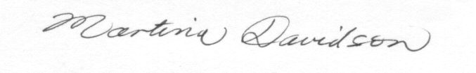

Martina Davidson
Exhibitions Organiser

enc

